EXPERIMENT – 07

STUDENT COUNSELLING SYSTEM

Aim
To design and deploy a Student Counselling System using Zoho Creator to demonstrate Software as a Service (SaaS), where student information and counselling preferences are managed online.

Procedure
- Step 1: Login to Zoho Creator.
- Step 2: Create a new application named 'Student Counselling System'.
- Step 3: Create a form with Student Name, Age, Address, Phone, Subjects Studied, Year of Passing, Percentage of Marks and Domain Interest.
- Step 4: Create reports to manage student counselling records.
- Step 5: Deploy the application on the cloud.

Fields Used
Field Name | Field Type | Description
Student Name | Name | Student full name
Age | Number | Student age
Address | Multi Line | Residential address
Phone | Phone | Contact number
Subjects Studied | Multi Line | Subjects completed
Year of Passing | Number | Passing year
Percentage of Marks | Decimal | Overall percentage
Domain Interest | Dropdown | Preferred domain

Application Screenshot

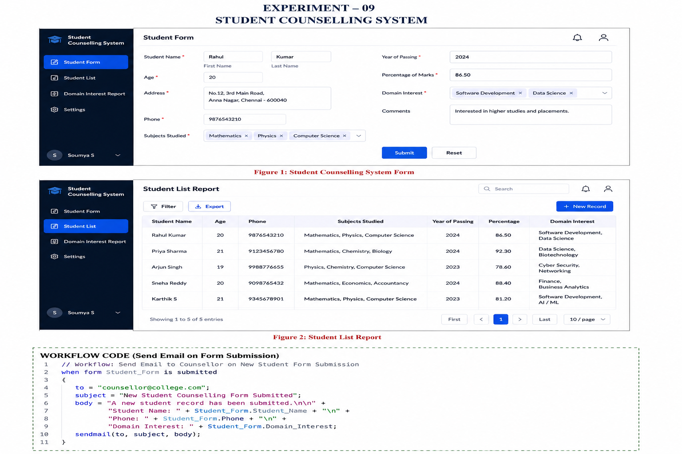
Figure 1: Student Counselling System Form





Result
A Student Counselling System SaaS application was successfully designed. The application stores student details, academic information, and domain interests, making the counselling process accessible online through the cloud.

